VSRT/VSRC
Evolution and History through the 20th Century

1940s-1960s

1946: The Inhalation Therapy Association (ITA) is formed in Illinois.

1954: The ITA is renamed as the American Association of Inhalation Therapists (AAIT).
1966: The AAIT is renamed as the American Association for Inhalation Therapy (still AAIT).

1970s

1970: The Maryland-D.C.-Virginia Society of the AAIT was established with one President elected from the society. Three Vice Presidents were elected from Virginia, one from each of the relatively equal sized regions in the state.

1973: The AAIT becomes the American Association for Respiratory Therapy (AART).
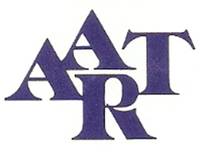
1973: The MD-D.C.-VA society was renamed the MD-DC-VA Society for Respiratory Therapy.

1974: Virginia respiratory therapy professionals voted to establish the VSRT.

1975: The VSRT was established as a separate society of the AART with AART permission and the state was divided into four areas designated as chapters; later chapter lines were redrawn to divide the four areas into five, separating one large area into Central and Blue Ridge districts and continuing the other three of Northern, Western, and Tidewater.

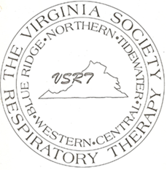
1977: VSRT began to seek state credentialing for respiratory therapy, prompted by the AART and its Board of Medical Advisors to insure professional survival beyond the 1990s.

1978: The first VSRT Spring Symposium was held in Virginia Beach.

1980s

1982: The first fall program was held in Abingdon. All subsequent Mountain Air Symposiums have been held in Blacksburg.

November 30, 1982: A VSRT position statement on state licensure was adopted, then revised on January 1, 1983.

January 26, 1983: The RT scope of practice for Virginia was developed and support was given by the Virginia Thoracic Society and Lung Association due to the efforts by “Chip” Robertson, MD, co-Medical Advisor of the VSRT.

October 4, 1983: The Virginia Commission of Health Regulatory Boards voted 10-0 in favor of regulating the practice of respiratory therapy in Virginia. Their recommendation was to regulate R.T. through statutory certification.

1984: The American Medical Association sanctioned a name change from “respiratory therapy” to “respiratory care,” prompted by the AART and supported by the American College of Chest Physicians, the American Society of Anesthesiologists, and the American Thoracic Society.

March 18, 1985: Virginia Governor Charles Robb signed the bill into law which established certification for Virginia respiratory therapy practitioners, however it was voluntary. The credential was Certified Respiratory Therapy Practitioner, designated by C.R.T.P.

July 1985: An Executive Director, Alan A. Smith, Jr., was employed to assist the VSRT in its operations. This service provided a central telephone number and mailing address for the society.

May 22, 1985: The VSRT holds its first casino night at the spring symposium in Virginia Beach.

1986: Vita L. Iocco became the Assistant Executive Director of the VSRT. Her responsibilities included obtaining vendor support for the VSRT conferences, organizing and updating the membership database, and publishing the VSRT’s newsletter, the VQ.

1986: The AART is renamed the American Association for Respiratory Care (AARC).
1987: The VSRT changes its name to the VSRC, effective April 17. 1987, per membership vote.

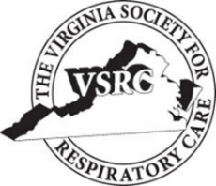

1987: The paid executive office services were cut back due to financial constraints. The new contract effective July 1, 1987 reduced assistance with publishing VQ, requiring more efforts from volunteer members in soliciting advertising and mailings. The paid services would continue to print the VQ and maintain the VSRT’s permanent files.
1990s

April 1990: Mandatory certification bill signed by Virginia Governor Douglas Wilder which provided title protection, effective July 1, 1990.

1992: Respiratory Care Week was established by the AARC, celebrating October 4-10 with the theme “Respiratory Care Cares about Children with Asthma.” Virginia Governor Douglas Wilder signed the formal declaration for Virginia on September 22, 199.2

1993: The first professional poster presentations were held at the spring symposium.

1994: The Virginia Community College System selected Respiratory Care to pilot the Distance Learning Project in Virginia due to well defined educational criteria, willingness of educators to support the programs, and regional shortage of practitioners.

1998: The VSRC Scholarship (often referred to as the Vendors’ Scholarship) was renamed the Leslee Harris Smith Scholarship fund in honor of Leslee who had been a strong contributor to both the state society and respiratory therapy education. Board members met at Leslee’s home to honor her on April 16, 1998.

April 22 1998: Gov. James Gilmore signed the Respiratory Care Practitioner licensure bill into law.

July 1, 1998: Respiratory Care Practitioner (RCP) licensure effective due to error in documentation instead of the intended date of July 1, 1999.

January 1, 1999: The regulations for the RCP licensure became effective.

