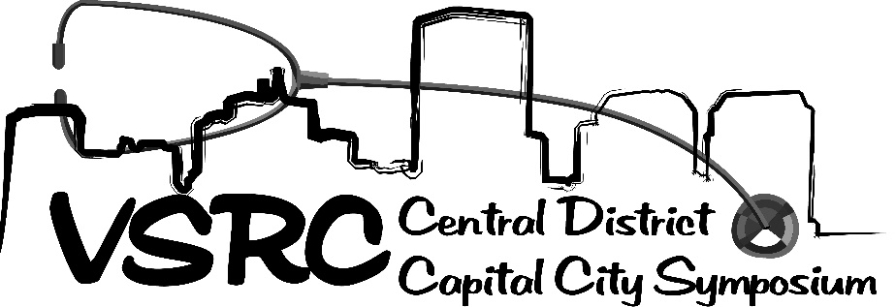
Vendor Brochure
Friday, March 20, 2020

Colleagues: Join us for the one-day conference on respiratory care topics sponsored by the Virginia Society for Respiratory Care Central District which:
- is targeted to respiratory therapists and decision makers
- has historically been attended by over 100 participants (2017-18)
- will have an application made to the American Association for Respiratory Care (AARC) for 6 continuing respiratory care education (CRCE) hours.

General Information and Fees:
Friday, March 20, 2020
Reynolds Community College, Parham Road Campus, Lily Pad Room
1651 East Parham Road, Richmond, VA 23228

Fees:
Vendor exhibit booth (6 ft. table): $300.00
Breakfast Sponsorship: $150.00
Lunch Sponsorship: $150.00
For meal sponsorships, signage will be placed on the food and beverage tables with the sponsoring company name(s) and acknowledgement will be included in the announcements and on agenda.

Registration online at https://www.vsrc.org/conference-registration/capital-city-symposium-vendor-sponsorship/
Payment may be made credit, debit, or by check.
Check may be made payable to “The Virginia Society for Respiratory Care” and mailed to:
VSRC Treasurer Chase Poulsen
7059 Linn Cove Court, Roanoke, VA 24018

Exhibit Hours, Setup and Breakdown:
Exhibit Set-up: Friday, March 20th, 6:30am and breakdown to be completed by 5:00pm. Exhibit area will be open from 7:30am to 5:00pm, and participants will be encouraged to visit exhibits:
7:30-8:30am during registration and continental breakfast
10:30-11:00am during break
12:00-1:00pm during lunch
2:15 – 2;30pm during break

Directions and Parking:
1651 East Parham Road, Richmond, VA 23228
Massey Technology Center building, Lily Pad Room
Park in the general parking lot and bring supplies into building. There is a sidewalk ramp to the left of the Massey Technology Center entrance. The Lily Pad Room and the symposium exhibit area are immediately inside the main entrance doors on the ground floor to the right.

Virginia Society for Respiratory Care (VSRC) Vendor Rules and Regulations
Capital City Symposium: Friday, March 20th, 2020

Exhibit booth includes one 6-foot table, two chairs. This price covers admission to exhibit area, all lectures, food, and beverages. The booth fee covers 2 vendor badges with each table and one additional badge may be purchased for $100.

Liabilities
Exhibitor agrees to indemnify the VSRC against and hold it free from any and all claims arising from loss or damage to Exhibitor’s property whatsoever cause occasioned, and wheresoever’s such property is located during the period in which VSRC occupies the Reynolds Community College property, except for such injury or loss as may be proximately caused by willful and malicious misconduct on the part of any conference committee member of the VSRC. Exhibitor agrees to indemnify the VSRC and the Reynolds Community College from and against any and all claims, losses or damages to persons or property
Admissions
All persons visiting the exhibit area will be admitted according to the rules and regulations of the exhibit as issued or amended by the authorized representatives for the VSRC.
Objectionable Material and Activities
Authorized representatives of the VSRC reserve the right to request modification of any questionable exhibit. Flammable substances are subject to local fire code.
It is the responsibility of each company to appropriately transport booth equipment at its own expense.
Agreement
By purchasing this booth, the exhibitor agrees to abide by these rules and regulations and the decisions of the VSRC. Failure to abide by these rules may result in expulsion from the planned event and future VSRC events.
Registration Process
All vendor registration will be handled online through the website www.vsrc.org.
Processing of Fees:
During the registration process you will be asked to provide payment via credit card or check.
Payment may be made via credit, debit or by check. Check may be made payable to “The Virginia Society for Respiratory Care” and mailed to:
VSRC Treasurer Chase Poulson
7059 Linn Cove Court, Roanoke, VA 24018
Tax ID# is available upon request from the VSRC Treasurer at VSRCtreas@gmail.com
Payment and Cancellations
Payment is expected prior to the conference date. In the event of a cancellation by the exhibitor, the VSRC has the right to retain booth fees if a cancellation is received less than 7 days prior to the scheduled event. The VSRC also has the right to rent the vacated space to another vendor once a cancellation is confirmed between the requesting vendor and an identified VSRC vendor coordinator.
Security
The VSRC nor Reynolds Community College, assume responsibility for the loss of, or damage to, exhibitors’ property. Exhibitors are encouraged to take precautions to protect their own property and to arrange for appropriate insurance against loss.
Continuing Education Credit
Vendor representatives who are registered as exhibitors may receive applicable continuing education credits for attending the education programs.
Cancellation Policy
It is policy of the VSRC that all cancellations must be submitted in writing, 1 week (7 calendar days) before the scheduled event to be eligible for a registration fee refund. Emergency Cancellations will be reviewed by the VSRC Executive Board of Directors and refund eligibility will be decided on a case by case basis.

For additional information, contact:
Jessica Weirup, BSRT, RRT-ACCS, Capital City Symposium Chairperson: jmweirup@gmail.com

VSRC Capital City Symposium Setup

