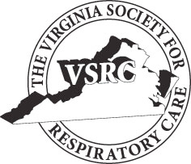
The
Virginia Society for Respiratory Care
is proud to present
The 39th Annual
Mountain Air Symposium

October 19th, 2020

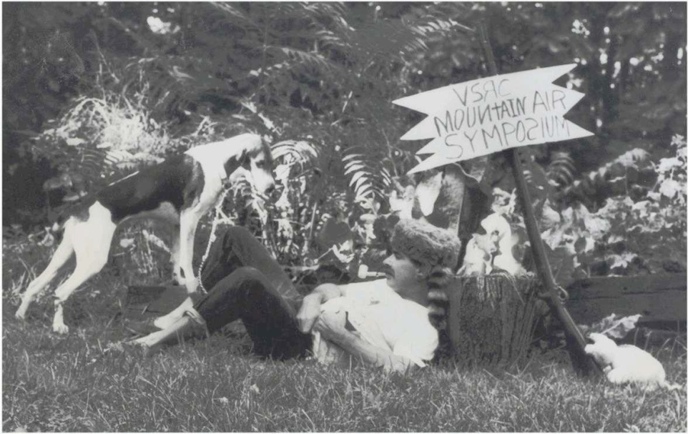

October 19th, 2020
2020 Participant Package
Host Location
Virtual Symposium

Join us for the 39th Annual Mountain Air Symposium sponsored by the Virginia Society for Respiratory Care.

The VSRC is hosting its fall program this year on October 19th-20th in a Virtual format. We are sure you will thoroughly enjoy the casual atmosphere of this format.

Once again the Program Committee has developed an outstanding lineup of speakers and topics. Join us for an excellent, two-day conference on respiratory care topics sponsored by the Virginia Society for Respiratory Care. Respiratory therapists, respiratory care students, nurses, and any
Healthcare practitioners are welcome to attend. Application being made to the American Association for Respiratory Care (AARC) for 6 hours of continuing respiratory care education (CRCE) hours. Partial
CRCE credit can be earned for partial conference attendance. Register at www.vsrc.org.

The Virtual Symposium has been broken up into a two-day program; three speakers will be offered each day with an opportunity to earn 3 CRCE’s for a total of 6 CRCE for the entire program.

Registration Fees

AARC Member No Fee
Non-AARC Member $10.00 per CRCE
Student No Fee
Active Duty Military No Fee

For additional information contact:
Shari Toomey, MBA, RRT-NPS
satoomey@carilionclinic.org
(540)263-2155

VSRC Mountain Air Symposium

Rrr

October 19th, 2020

0700-0800 Opening Remarks/Awards

0800-0900 An Update on Palliative Approaches to End of Life Care - Jeffrey E Goode MD
0900-0915 Vendor Speaker

0915-1015 Telehealth Strategies in COVID-19 Times - Melinda Schriver, MHA, MBA

1015 – 1030 Vendor Speaker

1030 – 1130 ARDS- Douglas Wright, Phd, RRT

October 20th, 2020

1200-1215 Introduction

1215-1315 The Overlap Syndrome- The Relationship between COPD and Apnea - JOSEPH ANDERSON, CCSH, RPSGT, RST, RPFT, CRT-NPS

1315-1330 Vendor Speaker

1330-1430 TBD

1430-1445 Vendor Speaker

1445-1545 Asthma – dogma, myths, and mistakes- Bruce K Rubin MEngr, MD, MBA, FAARC

