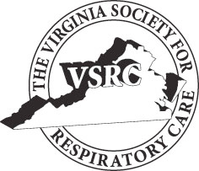
The
Virginia Society for Respiratory Care
is proud to present
The 39th Annual
Mountain Air Symposium

October 19 – 20th , 2020

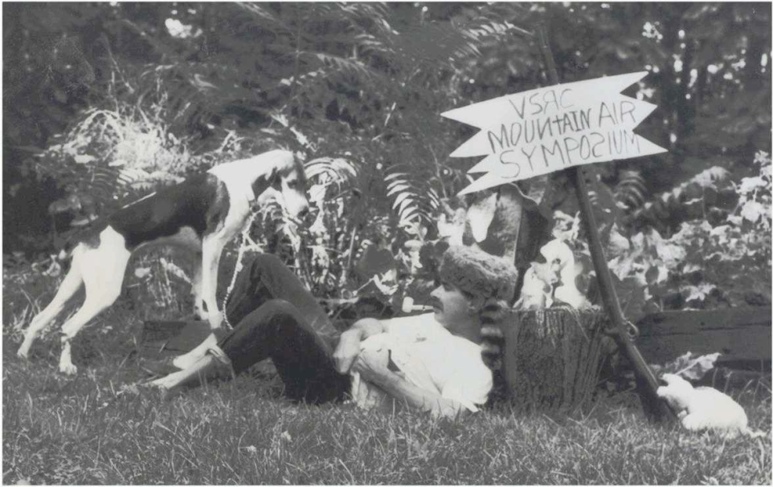

2020 Vendor Packet
Virtual Symposium
Join us for the 39th Annual Mountain Air Symposium sponsored by the Virginia Society for Respiratory Care.

The VSRC is hosting its fall program this year on October 19th-20th in a Virtual format. We are sure you will thoroughly enjoy the casual atmosphere of this format.

Once again the Program Committee has developed an outstanding lineup of speakers and topics. Join us for an excellent, two-day conference on respiratory care topics sponsored by the Virginia Society for Respiratory Care. Respiratory therapists, respiratory care students, nurses, and any
healthcare practitioners are welcome to attend. Application being made to the American Association for Respiratory Care (AARC) for 6 hours of continuing respiratory care education (CRCE) hours. Partial
CRCE credit can be earned for partial conference attendance. Register at www.vsrc.org.

The Virtual Symposium has been broken up into a two-day program; Three speakers will be offered each day with an opportunity to earn 3 CRCE’s for a total of 6 CRCE for the entire program.

General Information

Symposium Days/Hours:

Monday, October 19th, from 0800-1200

Vendor Times
Monday, October 19th, 2020

Vendor Time 0900-0915
Vendor Time 1015-1030

Tuesday, October 20th, 2020

Vendor Time 1315-1330
Vendor Time 1430-1445

Fee Schedule

Standard $150.00
The plan for participating vendors will be 15 minutes between each lecture to present information about your product that highlights its benefit to the various patient populations Respiratory Therapists work with. The cost for vendors to virtually showcase their product and/or service is $150.00. A list of vendors and contact information will be listed for participants to follow up with the vendors.

Registration and Payment:

Registration must be made via
www.vsrc.org and payment is expected prior to the date of conference.

Cancellation Policy:

It is policy of the VSRC that all cancellations must be submitted in writing, 7 calendar days before the scheduled event (October 19th, 2020) to be eligible for a registration fee refund. The VSRC Executive Board of Directors will review emergency cancellations and refund eligibility will be decided on a case by case basis. In the event of a cancellation by the exhibitor, the VSRC has the right to retain booth fees if a cancellation is received less than 7 calendar days prior to the scheduled event. The VSRC also has the right to rent the vacated space to another vendor once a cancellation is confirmed.

Objectionable Material and Activities:

Authorized representatives of the VSRC reserve the right to request modification of any questionable exhibit. Flammable substances are subject to local fire code. It is the responsibility of each company to appropriately transport booth equipment at its own expense.

Continuing Respiratory Care Education (CRCE) Credit:

For additional information contact:
Shari Toomey, MBA, RRT-NPS
satoomey@carilionclinic.org
(540)263-2155

Mountain Air Symposium Agenda

October 19th, 2020

0700-0800 Registration/Opening Remarks

0800-0900 An Update on Palliative Approaches to End of Life Care - Jeffrey E Goode MD
0900-0915 Vendor Speaker

0915-1015 Telehealth Strategies in COVID-19 Times - Melinda Schriver, MHA, MBA

1015 – 1030 Vendor Speaker

1030 – 1130 ARDS- Douglas Wright, Phd, RRT

October 20th, 2020

1200-1215 Registration/Opening Remarks

1215-1315 The Overlap Syndrome- The Relationship between COPD and Apnea - JOSEPH ANDERSON, CCSH, RPSGT, RST, RPFT, CRT-NPS

1315-1330 Vendor Speaker

1330-1430 TBD

1430-1445 Vendor Speaker

1445-1545 Asthma – dogma, myths, and mistakes- Bruce K Rubin MEngr, MD, MBA, FAARC

