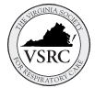
Join us for the 43rd Annual
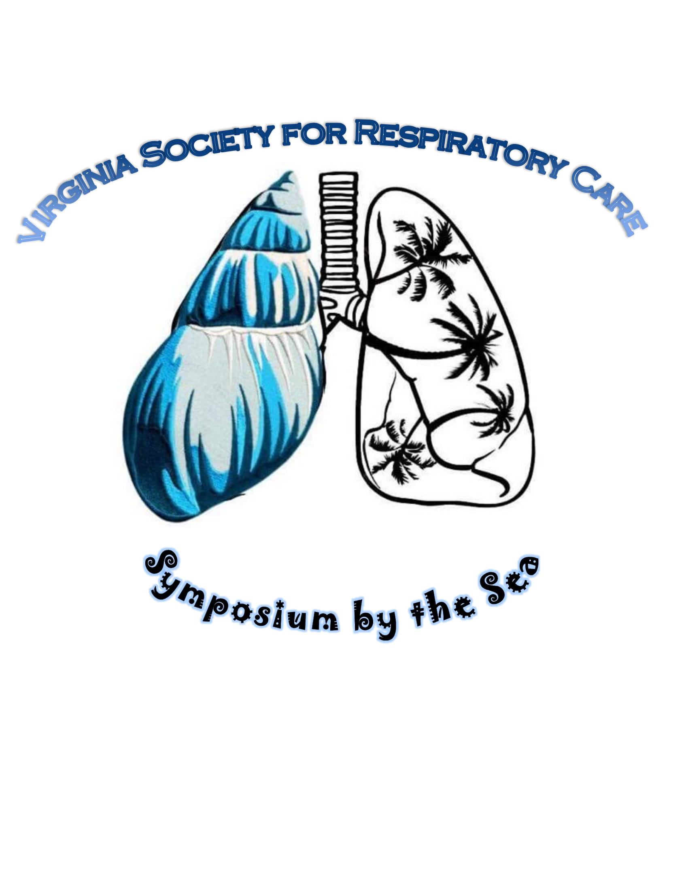
May 17-19th, 2021
Virginia Beach, VA
Masks required and 6ft social distancing rules apply in all areas
2021 Participant Packet
Host Hotel
Hilton Oceanfront
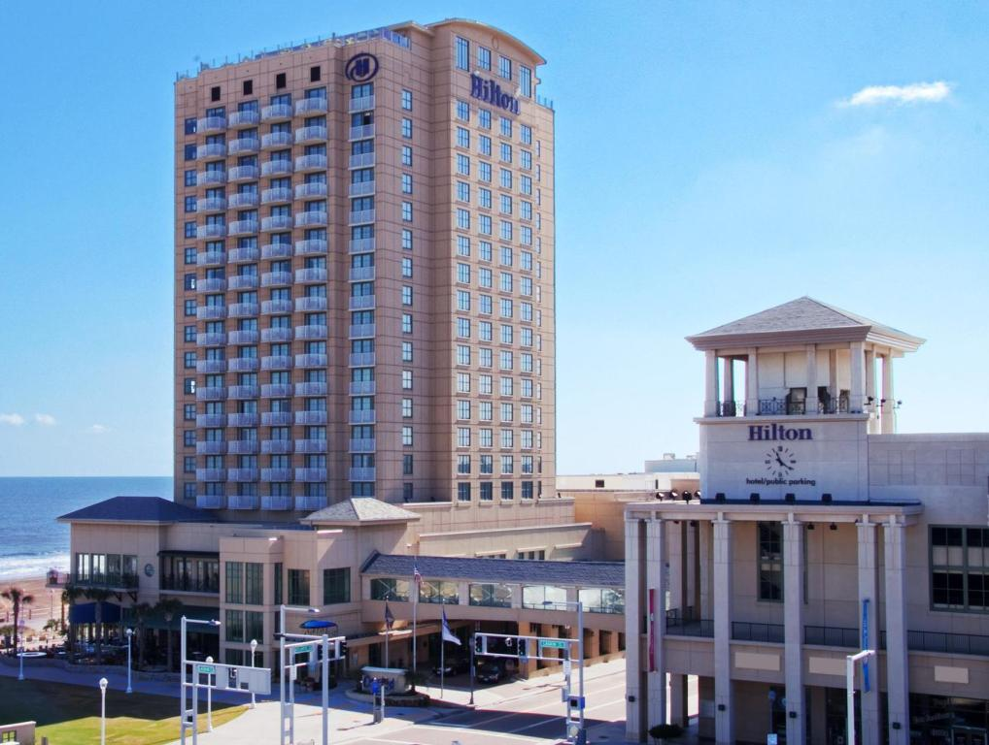
3001 Atlantic Ave, Virginia Beach, VA 23451
Phone: (757) 213-3000
Grab your mask and join us this year for a socially distanced good time and earn 10 CEUs!! Guests may make their discounted room reservation by either calling 757-213-3000 and ask for in-house reservation department and mention the VSRC
Or use the link https://www.hilton.com/en/hi/groups/personalized/O/ORFVHHF-VSR-20210515/index.jhtml?WT.mc_id=POG (you may need to change search dates to see all available rooms)
Room rates from $139 to $159 a night (taxes and fees extra) and must be booked by April 19th, 2021 to receive this discount.
The Hilton in response to social distancing and how they can maintain our safety.. “We are able to accomplish this by following all of the protocols that are provided by Hilton, thru Hilton EventReady with CleanStay, as well as the recommendations and mandates provided by the Commonwealth and the City of Virginia Beach.”
Fee Schedule
Early registration through April 30th, 2021
 |  |  | 1 Full day | 2 Full days | Three days Virtual Only
AARC Member early |  |  | $100 | $130 | $180 $60
AARC Member Regular |  |  | $120 | $150 | $220 $75
Non-AARC Member early |  |  | $150 | $175 | $275 $100
Non-AARC Member Regular |  |  | $170 | $195 | $325 $125
Student AARC Member early |  |  | $40 | $50 | $80
Student AARC Member Regular |  |  | $60 | $70 | $140
Student Non-AARC Member early |  |  | $60 | $80 | $140
Student Non-AARC Member Reg. |  |  | $60 | $80 | $140
Active Military early |  |  | $40 | $60 | $80 $40
Active Military Regular |  |  | $60 | $80 | $140 $60

For those who want to virtually attend but still enjoy the ocean views from the Hilton can book a room, show proof of booking, and receive a discount code for virtual only attendance!! Email Susan Arrington srg7a@virginia.edu with Hilton confirmation number to receive your discount code!
Tuition savings opportunity!! Can’t find the money to register for symposium? Consider the sputum bowl. The first two professional and student teams to register for sputum bowl get FREE registration to all three days!! Contact Megan Keith mkeithrrt@gmail.com by May 1st, 2021!
Three day registration comes with a FREE drink ticket to be used at Sips by the Sea or Sputum Bowl!!
2021 VSRC Symposium by the Sea
Schedule of Events:
Sunday May 16th 4pm-6pm
Pre Symposium registration and Sips by the Sea with the vendors
(Get your registration packets early to avoid the line in the morning, and spend some time with our vendors learning about new products, while enjoying a beverage and of course social distancing!)
Monday May 17th 8:30am-3:30pm
8:30 Registrations/Breakfast
9:30 Color Guard/Opening Remarks
10:00 to 12:00 Lectures
12:00 to 1:30 Lunch provided/vendor hall/awards
1:30 to 3:30 Lectures
Tuesday May 18th 9:00am-3:00pm & 6:00pm-8:00pm
9:00-10:00 Breakfast with the vendors
10:00-12:00 Lectures
12:00-1:00 Lunch provided/vendor hall/silent auction
1:00-3:00 Lectures
6:00-8:00 Sputum Bowl (beverages and light hors d’oeuvres)
Wednesday May 19th 9:00am-12:00pm
9:00-10:00 Breakfast
10:00-12:00 Lectures (certificate distribution after last lecture)
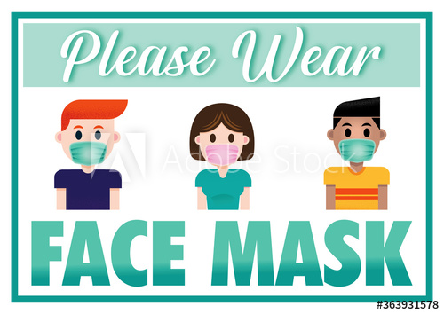
Socially Distanced Conference Room!!

2021 VSRC Symposium by the Sea

Please register online at www.vsrc.org
Actual schedule of lectures/presenters to come later
The VSRC has and will take all precautions to maintain everyone’s health and safety while attending Symposium by the Sea so we ask that everyone please wear a mask, and keep 6 ft of distance whenever possible

Any questions or comments please email Susan Arrington @ srg7a@virginia.edu

