2021 Symposium by the Sea
Monday, May 17th 2021
8:00 Registration/Breakfast
9:00 Opening Remarks by President Ryan Sharkey
9:30 3rd annual Dr. Charles Durbin Lecture given by Dr. Bruce Rubin
The Future of Respiratory Therapy
10:30 Susan Swedish RRT
Ventilator Management of the Asthmatic Patient
11:30 Stephen Richey RRT
Pulmonary Complications of Illicit Drugs and Prescription Medications
12:30-1:30 Lunch provided/vendor time
1:30 Andrew Miller RRT
Battling Burnout in Respiratory Care
2:30 Dan Rowley RRT
Prevention of aerosol dispersion and infection transmission during respiratory care procedures
6:00pm Sputum Bowl (cash bar & hors d’oeuvres)

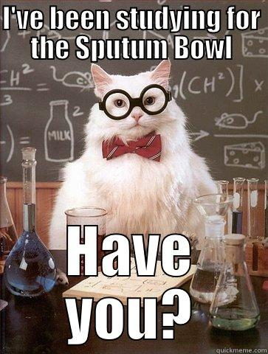
2021 Symposium by the Sea
Tuesday, May 18th 2021
8:00 Breakfast with the vendors- SPONSORED BY DRAEGER
9:00 John Lindsey RRT
Respiratory Care Profession, it’s more than just a career
10:00 Richard Hinds RRT
Shifting our view of pulmonary gas exchange; Lessons learned from COVID19
11:00 Dave Lockwood RRT Sponsored by Percussionaire
High Frequency Percussive Ventilation as a Therapy and Mode of Ventilation
12:00-1:00 Lunch provided/vendor time
1:00 Mike Davis RRT
Respiratory Therapy Research as a Career
2:00 Mandy Devries RRT
“TBD”

Last chance to see vendors, vendors close at 4:30pm!

2021 Symposium by the Sea
Wednesday, May 19th 2021

8:00 Breakfast
9:00 Joe Anderson RRT
Cognitive Behavioral Therapy to Improve Insomnia
10:00 Dr. Adam Hennessey Sponsored by Vapotherm
No Mask No Problem, Mask Free NIV
Certificate distribution after last lecture!
2021 Symposium by the Sea
Sunday May 16th, 2021

Join us for a special event Sunday evening from 4-6pm!!
The VSRC wants to say “thanks to all RTs for their hard work and dedication this past year” by hosting an open bar from 4-5pm during our Sips by the Sea preregistration vendor event!

Avoid the crowd in the morning and pick-up your registration packet early, while also getting special time with the vendors

