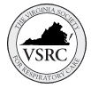
Join us for the 44th Annual
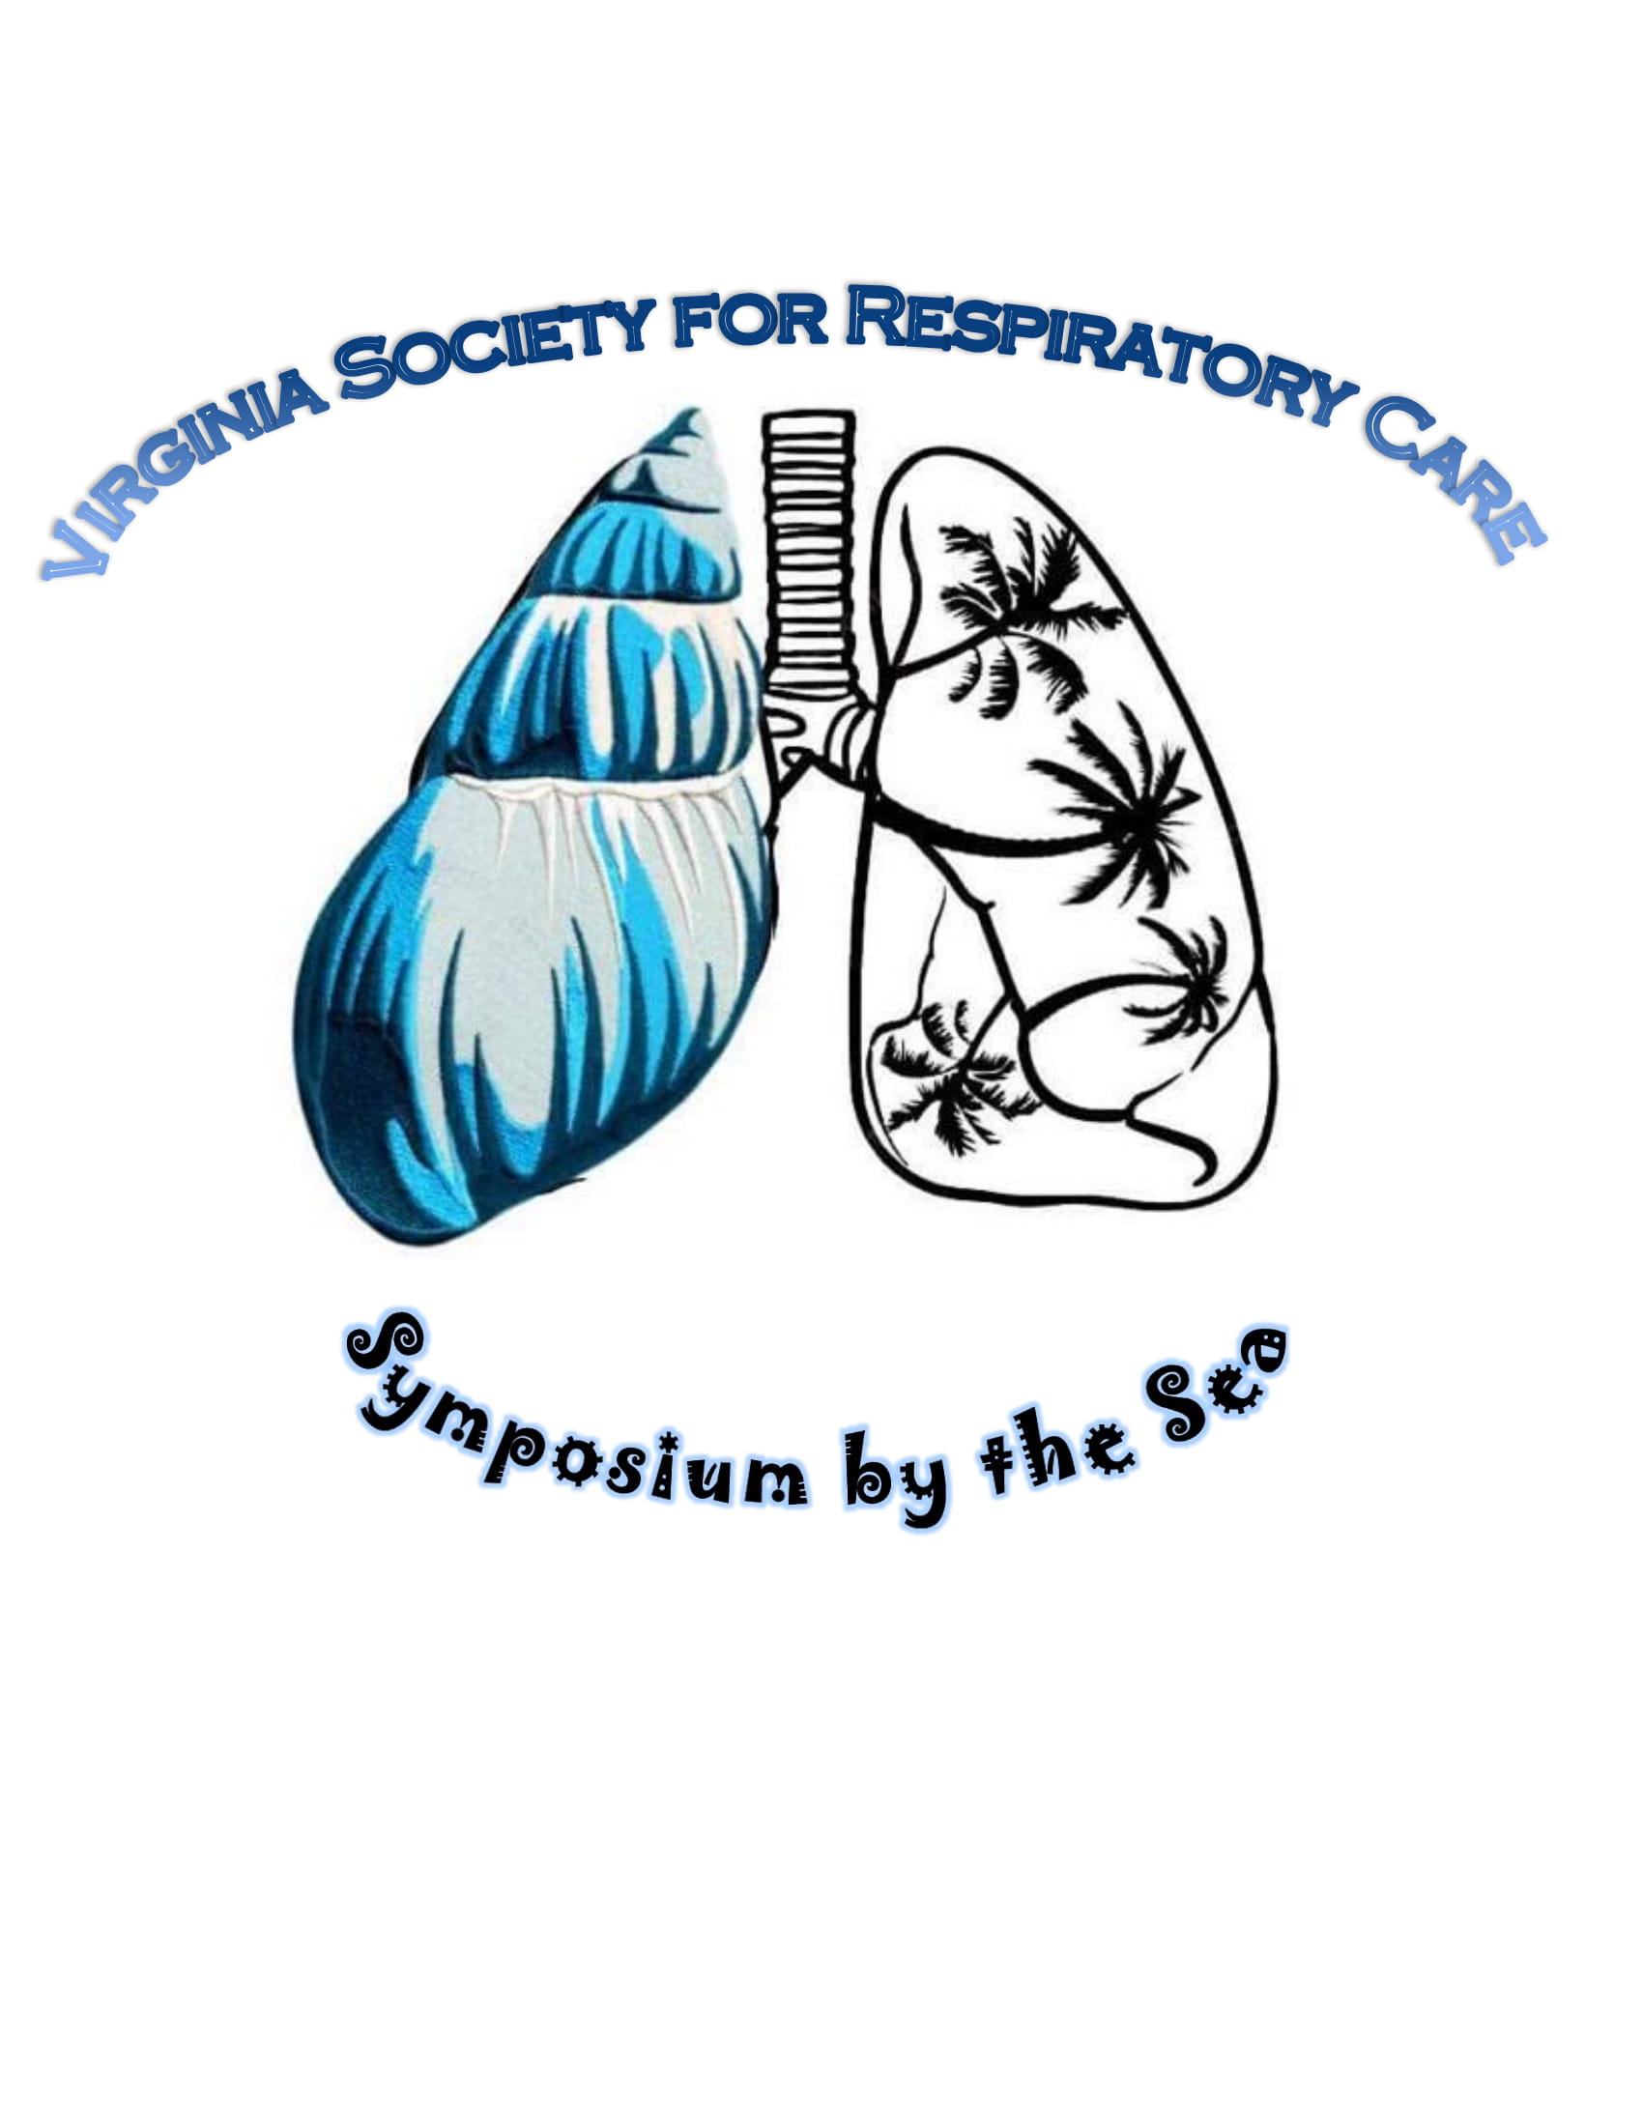
May 16-18th, 2022
Virginia Beach, VA
2022 Participant Packet
Host Hotel
Hilton Oceanfront
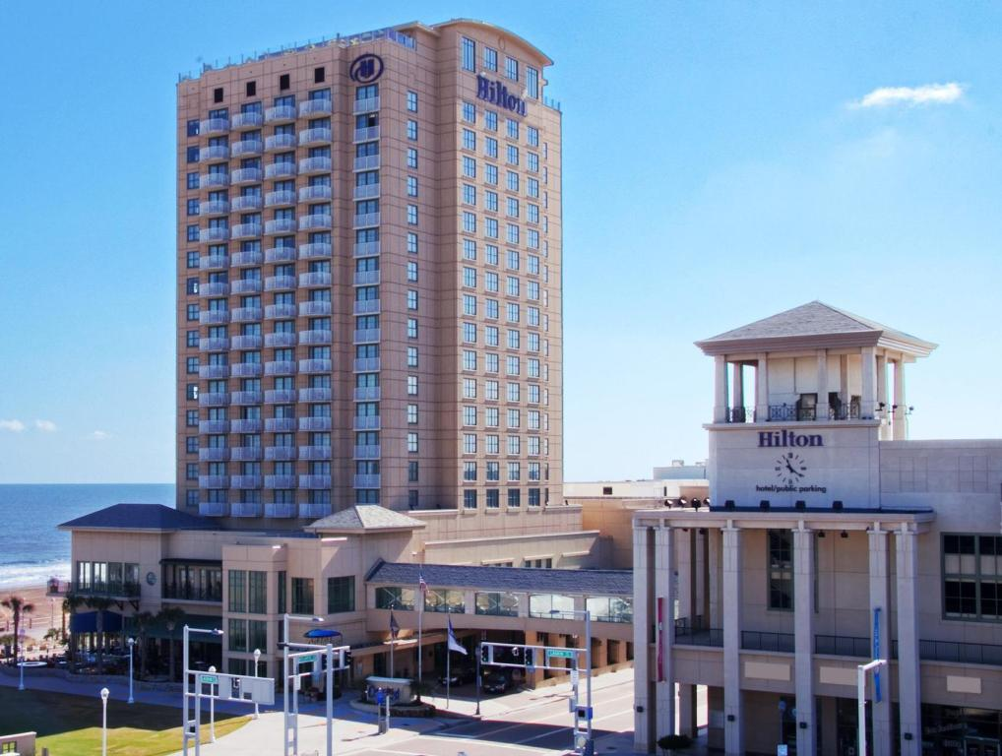
3001 Atlantic Ave, Virginia Beach, VA 23451
Phone: (757) 213-3000

Join us this year for amazing lectures, lots of fun and earn 15 CEUs!! Guests may make their discounted room reservation by either calling 757-213-3000 and ask for in-house reservation department and mention the VSRC
Or use the link VSRC SYMPOSIUM 2022 (hilton.com)
Room rates from $139 to $159 a night (taxes and fees extra) and must be booked by April 20th, 2022 to receive this discount.
2022 VSRC Symposium by the Sea
Fees:
Early registration ends April 30th, 2022
 |  |  | 1 Full day | 2 Full days | Three days Virtual Only
AARC Member early |  |  | $130 | $180 | $220 $100
AARC Member Regular |  |  | $155 | $200 | $255 $125
Non-AARC Member early |  |  | $180 | $210 | $275 $125
Non-AARC Member Regular |  |  | $200 | $230 | $315 $155
Student AARC Member early |  |  | $50 | $80 | $110
Student AARC Member Regular |  |  | $80 | $100 | $135
Student Non-AARC Member early |  |  | $80 | $100 | $135
Student Non-AARC Member Reg. |  |  | $100 | $120 | $165
Active Military early |  |  | $100 | $140 | $175
Active Military Regular |  |  | $125 | $165 | $225
For those who want to virtually attend but still enjoy the ocean views from the Hilton can book a room, show proof of booking, and receive a discount code for virtual only attendance!! Email Susan Arrington srg7a@virginia.edu with Hilton confirmation number to receive your discount code! (Please remember it is Virtual only attendance, does not include social events or food)
Money saving opportunity!! Can’t find the money to register for symposium? Consider the sputum bowl. The first two professional and two student teams to register for sputum bowl get FREE three day registration!! Contact Megan Keith mkeithrrt@gmail.com by May 1st, 2022! (a team consists of 3 members)
Three day registration comes with FREE drink tickets to be used at Sips by the Sea or Sputum Bowl!!
2022 VSRC Symposium by the Sea
Schedule of Events:
Sunday May 15th 4pm-6pm
Pre Symposium registration and Sips by the Sea with the vendors
(Get your registration packets early to avoid the line in the morning, and spend some time with our vendors learning about new products, while enjoying a beverage and snacks.)
Monday May 16th 8:00am-4:00pm & 6:00pm-8:00pm
8:00 Registrations/Breakfast (provided)/Vendor Hall open
8:30 Opening Remarks
9:00 to 12:00 Lectures
12:00 to 1:00 Lunch (provided)/vendor hall
1:00-4:00 Lectures
(vendor hall open till 5pm)
6:00-8:00 Sputum Bowl (food provided, beverages available)
Tuesday May 17th 8:00am-4:00pm
8:00-9:00 Breakfast (provided) /Vendor Hall open
9:00-12:00 Lectures
12:00-1:00 Lunch (provided)/vendor hall/silent auction
1:00-4:00 Lectures
(vendor hall open till 5pm)
Wednesday May 18th 8:00am-12:00pm
8:00-9:00 Breakfast (provided)
9:00-12:00 Lectures (certificate distribution after last lecture)
2022 VSRC Symposium by the Sea
Please register online at www.vsrc.org
Actual Schedule of lectures to come
Any questions please email Susan Arrington @ srg7a@virginia.edu

2022 VSRC Symposium by the Sea
Presenters:
Dr. Joshua Sill ? Medtronic sponsored
Dr. Xian Qiao ? MGC sponsored
Dr. Michael Eggert ? Grifols sponsored
Dr. Jay Collins ? Vapotherm sponsored
Dr. Mary Baker
Dr. Mark Stoddard
Leslie Yancy, RRT
Susan Swedish, RRT
Dave Grooms, RRT
Stephen Richey, RRT
Chase Poulson, RRT

*Speakers subject to change without notice

