Join us for the 45th Annual

May 23-25th, 2023
Virginia Beach, VA
2023 Vendor Packet
Host Hotel
Hilton Oceanfront
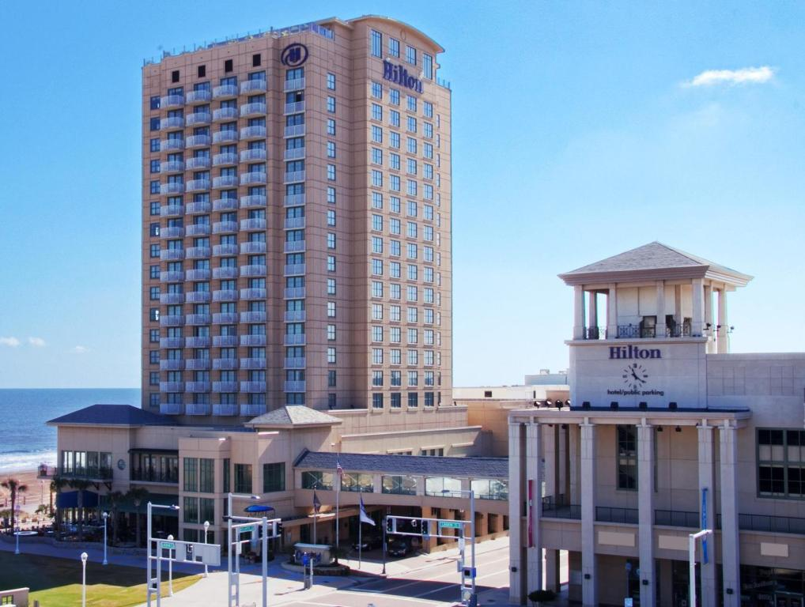
3001 Atlantic Ave, Virginia Beach, VA 23451
Phone: (757) 213-3000

Guests may make their discounted room reservation by either call-in 757-213-3000 and ask for in-house reservation department and mention the VSRC
or use the link VSRC Symposium 2023 (hilton.com)
Room rates from $149 to $169 a night (taxes and fees extra) and must be booked by April 27th, 2023 to receive this discount.

2023 VSRC Symposium by the Sea
Tentative Schedule of Events:
Tuesday May 23rd: 0730 vendor setup to begin
8:00am-4:00pm & 6:00pm-8:00pm
8:00 Registrations/Breakfast/Vendor hall opening
8:30 Opening Remarks
9:00 to 12:00 Lectures
12:00 to 1:00 Lunch provided/vendor hall
1:00-4:00 Lectures
(Vendor hall to remain open till 5pm)
6:00-8:00 Social Night (all attendees, speakers and vendors welcome) food provided/cash bar
Wednesday May 24th: 8:00am-4:00pm
8:00-9:00 Breakfast (vendor hall open)
9:00-12:00 Lectures
12:00-1:00 Lunch provided/vendor hall/silent auction
1:00-4:00 Lectures
(Vendor hall to remain open till 5pm)
6:00- Sputum Bowl (food provided/cash bar)
Thursday May 25th: 8:00am-12:00pm
8:00-9:00 Breakfast
9:00-12:00 Lectures (certificate distribution after last lecture)

Exhibitor Fee Info
Standard Booth $1200.00
Booths include one 6' table, two chairs, and two exhibitor badges. (Additional representative badges may be added for a fee of $100.00, please limit total number of reps to 4).
EXCLUSIVE event sponsorships provide your company additional advertising! Sponsorship includes signage at event and recognition during the program
Social Night Event (5/23) $ 100.00
Lunch Sponsorships (5/23 or 5/24) $ 150.00
Sputum Bowl Sponsorship (5/24) $ 100.00
Breakfast Sponsorship (5/23 or 5/24 or 5/25) $ 100.00
Registration Process
All vendor registration will be handled online at www.vsrc.org. Payments may be made by credit card
Tax ID# (W-9 form) - Available upon request
Logistics:
Monday 5/22: Vendors can drop off items to store in the avamore room
Tuesday 5/23 – setup to begin at 0730 hall opens at 8:00 am
Wednesday 5/24- vendor hall opens at 8:00am
No vendors planned for half day Thursday.
Hilton will be responsible for installation and removal of the exhibits setup in accordance with the floor plan.
Each tabletop package will consist of the following:
• One 6 ft. x 2 ft. table with white vinyl top and flame-resistant fabric skirting
• Two folding chairs
• One wastebasket
• One 7” x 44” booth identification sign.

VSRC Rules and Regulations
Badges for Exhibitors Two (2) badges accompany the standard booth price. This price covers admission to vendor hall, lectures, all food provided and social events.
Liabilities
The exhibitor agrees that The Virginia Society for Respiratory Care, its agents, and its employees: (A) will not be responsible for any damage to or for the loss or destruction of the exhibitor’s property or injuries to the exhibitor, his representatives, agents or employees: all claims for any such loss, damage, destruction, or injury being expressly waived by the exhibitor; (B) will be exempted from or indemnified for any claims for injury to any exhibitor’s representatives or employees. The Virginia Society for Respiratory Care, its agents, and its employees will not be liable for failure to hold the exhibit as scheduled. Payments for booth space will be returned in that event except that no expenses incurred in connection with the exhibit will be deducted if the exhibit is called because of fires or any act of God, or public enemy, or strike, or epidemic, or any law or regulations of public authority, which makes it impossible or impractical to hold the exhibit.
Payment and Cancellations
The exhibitor will pay the cost of the space with the registration. Payment is due prior to the conference date. In the event of a cancellation by the exhibitor, the VSRC has the right to retain all booth fees if a cancellation is received less than 14 days prior to the scheduled event. If a cancellation is received 14 days or greater prior to the event, a fee of $200 may be retained. The VSRC also has the right to rent the vacated space to another vendor once a cancellation is confirmed. The VSRC will have sole control over all admissions of persons. All persons visiting the exhibit area will be admitted according to the rules and regulations of the exhibit as issued or amended by the authorized representatives of the VSRC.
Objectionable Material and Activities
Authorized representatives of the VSRC reserve the right to request modification of any questionable exhibit. Flammable substances are subject to local fire code. Contact the hotel convention coordinator for specific information.
Security
Despite these precautions, neither the VSRC nor the Hilton Virginia Beach Oceanfront Hotel can assume responsibility for the loss of, or damage to, exhibitors’ property. Exhibitors are encouraged to take precautions to protect their own property and to arrange for appropriate insurance against loss. {EXHIBITOR} hereby assumes entire responsibility and hereby agrees to protect, defend, indemnify and save Hotel, its owners, its operator, and each of their respective parents, subsidiaries, affiliates, employees, officers, directors, and agents harmless against claims, losses or damages to persons or property, governmental charges or fines and attorney’s fees arising out of or caused by its installation , removal, maintenance, occupancy or use of the exhibition premises or a part thereof, excluding any such liability caused by the sole gross negligence of Hotel and its employees and agents. {EXHIBITOR} shall obtain and keep in force during the term of the installation and use of the exhibit premises, policies of Comprehensive General Liability Insurance and Contractual Liability Insurance, insuring and specifically referring to the Contractual liability set forth in this agreement, in an amount not less than $2,000,000 Combined Single Limit for personal injury and property damage. Hotel, its owners and its operator shall be included in such policies as additional named insured’s. In addition, {EXHIBITOR} acknowledges that neither Hotel, its owners, nor its operator maintain insurance covering exhibitor’s property and that it is the sole responsibility of {EXHIBITOR} to obtain business interruption and property damage insurance insuring any losses.
Agreement
By purchasing this booth, the exhibitor agrees to abide by these rules and regulations and the decisions of the VSRC. Failure to abide by these rules may result in expulsion from the planned event.
Service Contractor
The Hilton has been designated as the official service contractor of the 44th Annual Symposium by the Sea.
Shipping Information
It is the responsibility of each company to appropriately ship booth equipment at their own expense.
Parking
Hilton Hotel Guest: Complimentary Self-Parking in the garage for overnight guests of the hotel. Valet parking for overnight guests is complimentary. Attendees who are not guests of the Hilton Hotel: Valet parking is complimentary for attendees of the meeting, mention VSRC. Garage parking for individuals attending a meeting is complimentary.
Questions? Contact:
Susan Arrington VSRC Vice President and Symposium Co-Chair @ suezndan@yahoo.com

2023 Symposium by the Sea
Vendor Hall Setup
Booth placement is first come first served when registering online (register early for good placement!)
Peacock Ballroom A
Doors
28
27
26
25
24
23
22
21
20
19
18
17
16
15
14
13
12
11
10
9
8
7
6
5
4

3
2
1

