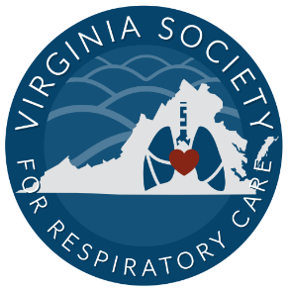

Join us for the 46th Annual

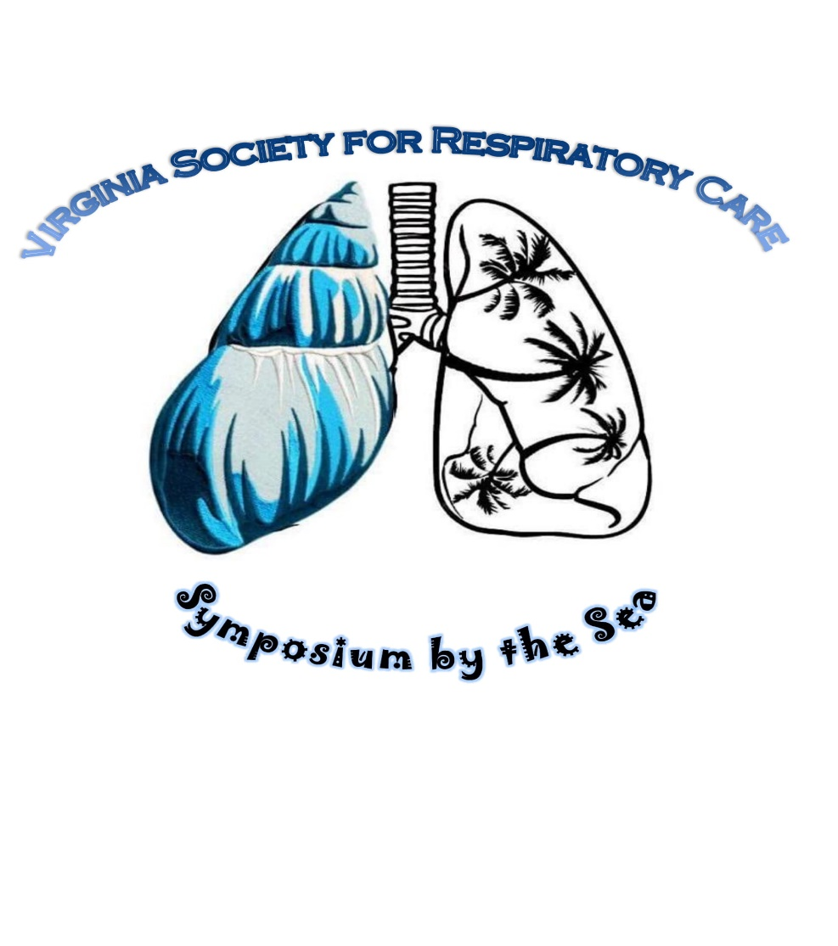

May 20-22nd 2024

Virginia Beach, VA

2024 Participant Packet

Host Hotel

Hilton Oceanfront

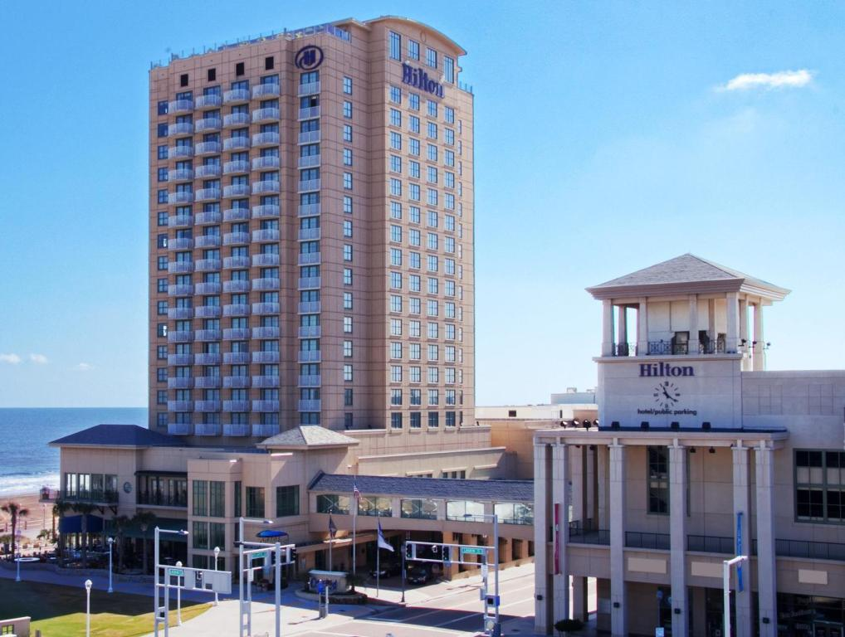

3001 Atlantic Ave, Virginia Beach, VA 23451

[**Phone**](https://www.google.com/search?sa=X&bih=1099&biw=1920&hl=en-US&q=hilton+virginia+beach+oceanfront+phone&ludocid=3875807469967397368&ved=2ahUKEwim5Z-o0K3vAhXkMlkFHT2uD1kQ6BMwFXoECBYQAg)**:**[(757) 213-3000](https://www.google.com/search?q=hilton+oceanfront+va+beach&source=lmns&bih=1099&biw=1920&hl=en-US&sa=X&ved=2ahUKEwjN6tXyz63vAhXDBt8KHU0UCFIQ_AUoAHoECAEQAA)

Join us this year for amazing lectures, lots of fun and earn **15** CEUs!! Guests may make their discounted room reservation by either calling 757-213-3000 and ask for in-house reservation department and mention the VSRC

Or use the link [2024 VSRC Symposium (hilton.com)](https://www.hilton.com/en/attend-my-event/orfvhhf-vsr4-85b4c269-d4d9-4333-9d58-48d02ff126e8/)

Room rates from $159 to $179 a night (taxes and fees extra) and must be booked by April 24th, 2024 to receive this discount.

Scan QR code for reservations 

2024 VSRC Symposium by the Sea

Fees:

|  |  |  |
| --- | --- | --- |
|  | | |
|  |  |  | **1 Full day** | **2 Full days** | **Three days** |  |
| **AARC Member Regular** | | | **$175** | **$200** | **$295** |  |
| Non-AARC Member Regular | | | $200 | $250 | $320 |  |
| **Student AARC Member Regular** | | | **$80** | **$125** | **$165** |  |
| Student Non-AARC Member Reg. | | | $100 | $140 | $185 |  |
| **Active Military Regular** | | | **$125** | **$165** | **$225** |  |

**Money saving opportunity!!** Can’t find the money to register for symposium? Consider the sputum bowl. The first **two** professional and **two** student teams to register for sputum bowl get **FREE** three day registration!! The VSRC will sponsor winning student sputum bowl team to attend AARC Congress Sputum Bowl for 2024!

Contact Susan Arrington at suezndan@yahoo.com by May 1st, 2024! (each team consists of 3 members all receive free registration)

Three day registration comes with 2 **FREE** drink tickets to be used at social night or sputum bowl!

2024 VSRC Symposium by the Sea

Schedule of Events:

*\*Schedule is subject to change without notice\**

**Monday May20th: 8am-5pm**

8:00 Registrations/Breakfast (provided)

8:55 Opening Remarks

9:00 to 11:00 Lectures

11:00 to 11:30 Vendor hall opening

11:30-12:30 Lecture

12:30-2:00 Lunch provided/vendor hall/silent auction

2:00-5:00 Lectures

(vendor hall open till 6pm)

6:00pm Social Night (small hors d’voeuvres provided, cash bar)

**Tuesday May 21st: 8:00am-5:00pm**

8:00-9:00 Breakfast (provided) /Vendor Hall open

9:00-12:00 Lectures

12:00-1:30 Lunch on your own (vendor hall open, silent auction)

1:30-2:00 Student session- Panel Q&A, interview tips/tricks

2:00-5:00 Lectures

(vendor hall open till 6pm)

7:00pm Sputum Bowl (cash bar)

**Wednesday May 22nd: 8:00am-12:00pm**

8:00-9:00 Breakfast (provided)

9:00-12:00 Lectures (certificate distribution after last lecture)

2024 VSRC Symposium by the Sea

Please register online at [www.vsrc.org](http://www.vsrc.org)

Actual Schedule of lectures to come

Any questions please email Santeria Brown-Yearling @ [rrtatnight@gmail.com](mailto:rrtatnight@gmail.com) or Susan Arrington @ [suezndan@yahoo.com](mailto:suezndan@yahoo.com)

2024 VSRC Symposium by the Sea

Presenters:

Carl Hinkson AARC President Kimberly Smith

Dr. Kevin Jackson Regina Rackow

Keith Lamb Jeri Prosser

David Grooms Scott Jones

Heather Chatfield Chandler Jones

Shane Blake Jared Rice

Wendy Castro Nathalie Chantree

Tim Sharkey

*Speakers subject to change without notice*