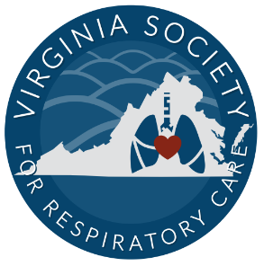
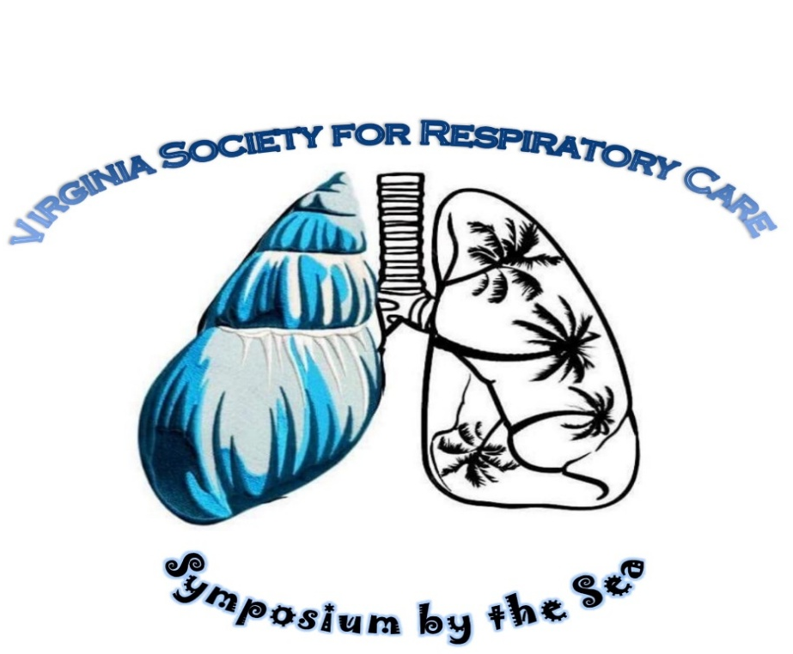
Join us for the 48th Annual

May 18th -20th 2026
Virginia Beach, VA
2026 Participant Packet
Conference Headquarters
Embassy Suites by Hilton Oceanfront Resort
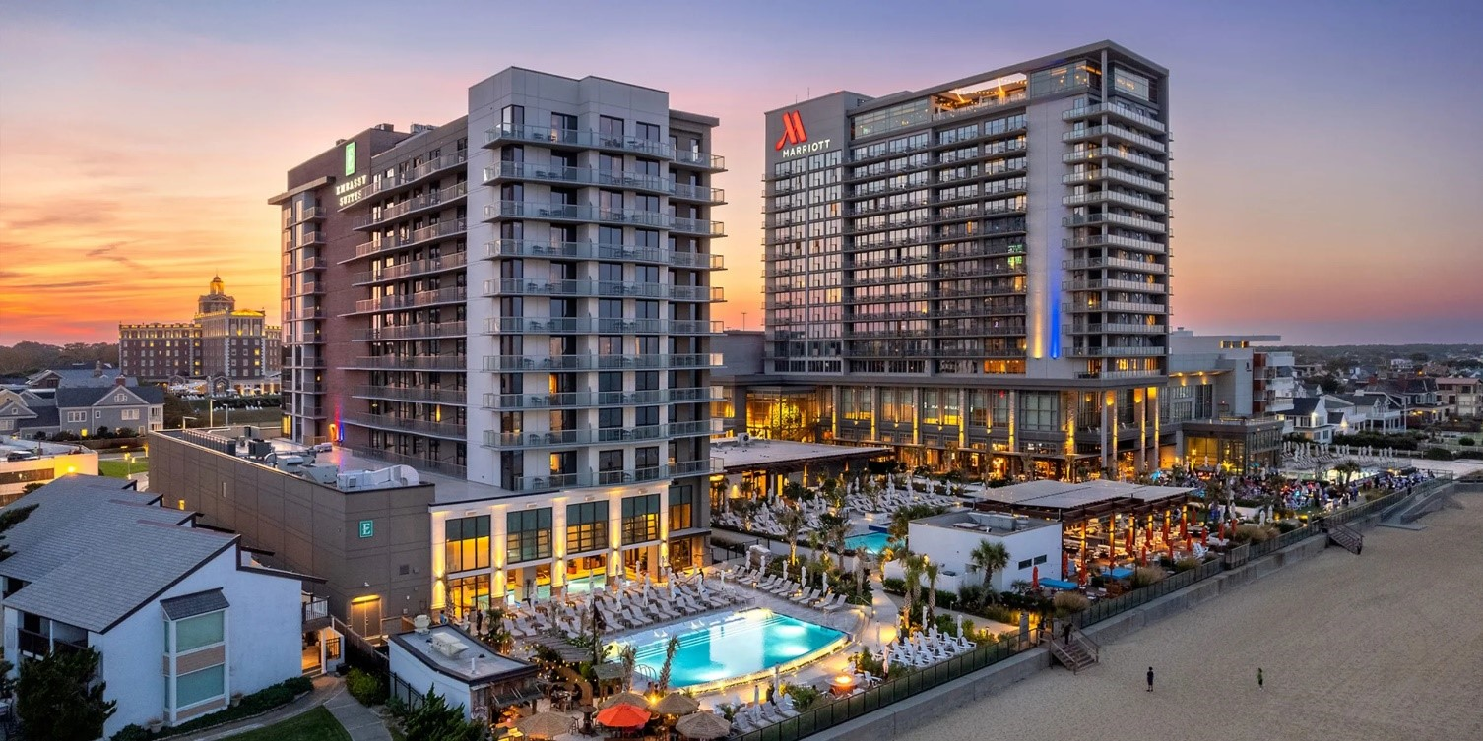
4101 Atlantic Ave, Virginia Beach, VA 23451
Phone: +1 757-228-3100


Join us for our new venue with amazing lectures, lots of fun and earn up to 18 CEUs! Guests may make their discounted room reservation by either calling and ask for in-house reservation department and mention the VSRC Discount or using this link 2026 Embassy Suites VSRC Discount Registration Link or QR code >

Room rates $219 a night (+taxes/fees) must be booked by April 24th, 2026 to receive this discount. Includes free breakfast daily at on site Arbuckles Restaurant and amenities to all three hotels of the Cavalier Resort including: 9 restaurants and bars, 6 pools indoor/ outdoor, distillery, etc!
Parking Garage on resort property across from main drive. Self-Parking is $26 per car per night for overnight guests. Valet parking available for additional $10.00 per day. Daily Guest Self-Parking is $3.00/hour.
Registration
***Early Registration ends May 1st. Rates go up after May 1st***
 |  |  | 1 Full day | 2 Full days | Three days
AARC Member Regular |  |  | $100 | $175 | $220
Non-AARC Member Regular |  |  | $150 | $200 | $275
Student AARC Member Regular |  |  | $25 | $50 | $75
Student Non-AARC Member Reg. |  |  | $50 | $75 | $100
Active Military |  |  | $100 | $175 | $200

***May 2nd – Day of event Fees***  AARC Member Regular | $175 | $250 | $285
Non-AARC Member Regular | $200 | $275 | $320
Student AARC Member Regular | $25 | $50 | $75
Student Non-AARC Member Reg. | $50 | $75 | $100
Active Military | $100 | $175 | $200

To register you will need to go to the Registration Page or scan the QR code:
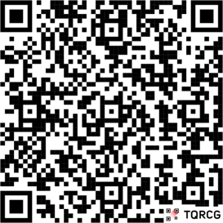

Money saving opportunity! Can’t find the money to register for symposium? Consider the Sputum Bowl. The first professional and first student teams to register for sputum bowl get FREE three-day registration!! The VSRC will sponsor the winning student sputum bowl team to attend AARC Congress Sputum Bowl for 2026! Contact Ali Brown by May 1st, 2026! (each team consists of 3 members all receive free registration)

Tentative Schedule of Events:
*Schedule is subject to change*
Monday May 18th: 8am-430pm
8:00 Check in
8:45 Welcome and Opening Remarks
9:00 to 11:00 Lectures
11:00 – 11:30 Vendor Hall opening/ Break
11:30-12:30 Lecture
12:30-130 Lunch provided/vendor hall
130-430 Lectures
(vendor hall open till 8pm)
5:30 – 7:30 pm Social Night with Vendors

Tuesday May 19th : 8:00am-4:30pm
8:00 Check in/Vendor Hall open
8:00-12:00 Lectures
12:00-1:30 Lunch Provided (vendor hall open)
1:30-2:30 Student Break Out Session
1:30-4:30 Lectures - Vendor hall open until 6:00 PM
5:00 – 7:00pm Sputum Bowl

Wednesday May 20th : 8:00am-12:00pm
8:00 Check In
8:30-12:30 Lectures (certificate distribution after last lecture)

*Detailed schedule of speakers and topics will be published when it becomes available.
Any questions please email Ali Brown at VSRCVP@gmail.com or Michelle Blake Mblake@tcc.edu.

