

Join us for the 48th Annual

May 18TH TO 20TH , 2026
Virginia Beach, VA
2026 Vendor Packet

Host Hotel
Embassy Suites
Part of the Cavalier Resort
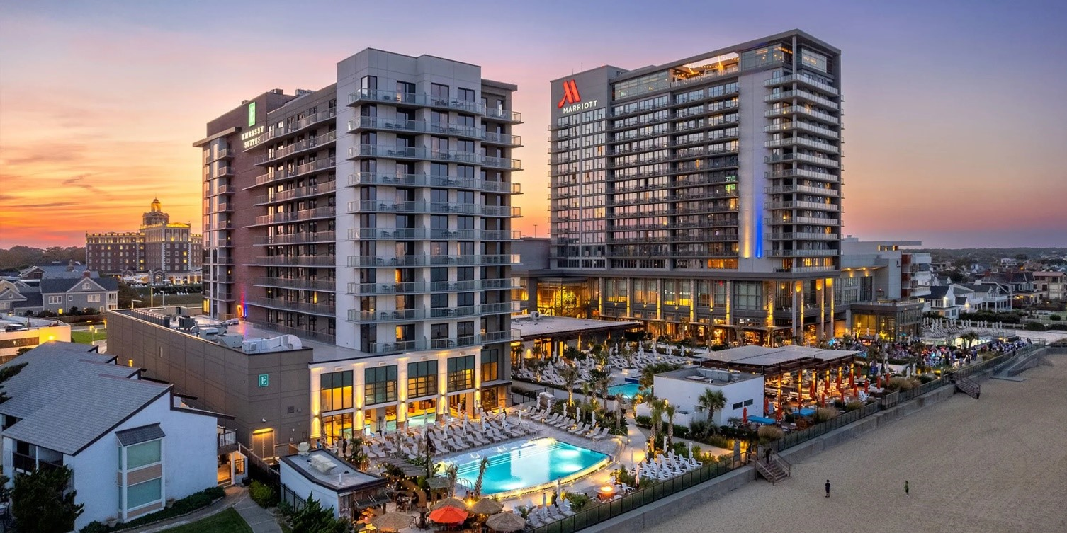
4101 Atlantic Ave, Virginia Beach, VA 23451
Phone: +1 757-228-3100


Guests may make their discounted room reservation by either call-in 757-213-3000 and ask for in-house reservation department and mention the VSRC
Or use the link 2026 Embassy Suites Reservation Link
Or Scan QR code

Room rates from $219 a night (taxes and fees extra) and must be booked until April 24th, 2026 to receive this discount. All rooms come with complimentary breakfast at the Restaurant Arbuckles, plus use of all amenities throughout the three hotels associated with the Cavalier Resort.

2026 VSRC Symposium by the Sea
Tentative Schedule of Events:
Monday May18th: 8am-430pm
8:00 Check in
8:45 Welcome and Opening Remarks
9:00 to 11:00 Lectures
11:00 – 11:30 Vendor Hall Open/ Break
11:30-12:30 Lecture
12:30-130 Lunch provided/vendor hall
130-430 Lectures
(vendor hall open till 8pm)
5:30 – 7:30 pm Social Night with Vendors
Tuesday May 19th: 8:00am-5:00pm
8:00 - Check-in (vendor hall open)
9:00-11:00 Lectures
11:00 - 11:30 Break with Vendors
1:30-4:00 Lectures
(Vendor hall to remain open 4:30)
5:00- Sputum Bowl (cash bar available)
Wednesday May 20th: 8:00am-12:00pm (Vendor Break Down)
9:00-12:00 Lectures

Exhibitor Fee Info
*Electricity included in all options*
Premium (Mainsail Prefunction) $1500.00
Includes premium booth placement upon entry to vendor hall in the Mainsail walkway, company name/logo displayed on all social media posts and any printed materials.
Standard/Regular (Lobby/Lounge) $1200.00 SOLD OUT
Balcony (Upper Mezzanine) $1000.00
Plus…
Sponsor options $500.00 each (vendor to choose specific sponsorship option, can pick more than one)
Company name/logo displayed during selected sponsor option. Company Name/Logo displayed on VSRC social media SBS event posts as sponsor. Company name/logo will be printed and placed in the SBS attendee packet as sponsor.
Lunch Sponsor – Monday
Lunch Sponsor – Tuesday
Event Sponsor – Sputum Bowl
Event Sponsor – Monday Night Social
Snack Sponsor – Monday (all day)
Snack Sponsor – Tuesday (all day)
All booths include one 6' table, two chairs, and two exhibitor badges. Round Top Tables for display only vendors, available on request. (Additional representative badges may be added for a fee of $100.00, please limit total number of reps to 4). Electricity is NOT included in all booths and must be requested at time of registration or before May 1st 2026.
Registration Process
All vendor registration will be handled online at www.vsrc.org. Payments may be made by credit card.
Tax ID# (W-9 form) - Available upon request
Logistics:
Sunday May 17th: Vendors can drop off items to be stored in the Leeward Office from 12pm – 5pm.
Monday May 18th: Setup to begin at 0700 Vendors can stay until 8pm. Social Hour is 5:30 -7:30pm
Tuesday May 19st: Vendors open at 8:00am and closes at 6pm
No vendors planned for Wednesday.
After each day, or when vendor is done for day:
-Can leave set up as is under vendor own discretion and liability
-Can place large equipment and boxes, etc. in office designated by the Embassy and VSRC staff overnight to be used again next day.
-Storage of items will be at discretion of VSRC Event Staff and Hotel Staff.
Embassy will be responsible for installation and removal of the exhibit’s setup in accordance with the floor plan.
Each tabletop package will consist of the following:
• One 6 ft. x 2 ft. table with white vinyl top and flame-resistant fabric skirting
• Two folding chairs
VSRC Rules and Regulations
Badges for Exhibitors Two (2) badges accompany the standard booth price. This price covers admission to vendor hall, lectures, all food provided and social events.
Liabilities
The exhibitor agrees that The Virginia Society for Respiratory Care, its agents, and its employees: (A) will not be responsible for any damage to or for the loss or destruction of the exhibitor’s property or injuries to the exhibitor, his representatives, agents or employees: all claims for any such loss, damage, destruction, or injury being expressly waived by the exhibitor; (B) will be exempted from or indemnified for any claims for injury to any exhibitor’s representatives or employees. The Virginia Society for Respiratory Care, its agents, and its employees will not be liable for failure to hold the exhibit as scheduled. Payments for booth space will be returned in that event except that no expenses incurred in connection with the exhibit will be deducted if the exhibit is called because of fires or any act of God, or public enemy, or strike, or epidemic, or any law or regulations of public authority, which makes it impossible or impractical to hold the exhibit.
Payment and Cancellations
The exhibitor will pay the cost of the space with the registration. Payment is due prior to the conference date. In the event of a cancellation by the exhibitor, the VSRC has the right to retain all booth fees if a cancellation is received less than 14 days prior to the scheduled event. If a cancellation is received 14 days or greater prior to the event, a fee of $500 may be retained. The VSRC also has the right to rent the vacated space to another vendor once a cancellation is confirmed. The VSRC will have sole control over all admissions of persons. All persons visiting the exhibit area will be admitted according to the rules and regulations of the exhibit as issued or amended by the authorized representatives of the VSRC.
Objectionable Material and Activities
Authorized representatives of the VSRC reserve the right to request modification of any questionable exhibit. Flammable substances are subject to local fire code. Contact the hotel convention coordinator for specific information.
Security
Despite these precautions, neither the VSRC nor the Embassy Suites Hotel can assume responsibility for the loss of, or damage to, exhibitors’ property. Exhibitors are encouraged to take precautions to protect their own property and to arrange for appropriate insurance against loss. {EXHIBITOR} hereby assumes entire responsibility and hereby agrees to protect, defend, indemnify and save Hotel, its owners, its operator, and each of their respective parents, subsidiaries, affiliates, employees, officers, directors, and agents harmless against claims, losses or damages to persons or property, governmental charges or fines and attorney’s fees arising out of or caused by its installation , removal, maintenance, occupancy or use of the exhibition premises or a part thereof, excluding any such liability caused by the sole gross negligence of Hotel and its employees and agents. {EXHIBITOR} shall obtain and keep in force during the term of the installation and use of the exhibit premises, policies of Comprehensive General Liability Insurance and Contractual Liability Insurance, insuring and specifically referring to the Contractual liability set forth in this agreement, in an amount not less than $2,000,000 Combined Single Limit for personal injury and property damage. Hotel, its owners and its operator shall be included in such policies as additional named insured’s. In addition, {EXHIBITOR} acknowledges that neither Hotel, its owners, nor its operator maintain insurance covering exhibitor’s property and that it is the sole responsibility of {EXHIBITOR} to obtain business interruption and property damage insurance insuring any losses.
Agreement
By purchasing this booth, the exhibitor agrees to abide by these rules and regulations and the decisions of the VSRC. Failure to abide by these rules may result in expulsion from the planned event.
Service Contractor
The Embassy has been designated as the official service contractor of the 2026 VSRC Symposium by the Sea.
Shipping and Receiving Information
It is the responsibility of each company to appropriately ship booth equipment at their own expense. Any materials being sent to the hotel must include the following information:
- Hold for arrival parentheses guests name and organization name
- Complete for return address
- Embassy’s representatives name
- Number of packages to be received (example: box one of two box two of 2 etc.)
- Date the function is being held
- Address package to hotel as follows:
Embassy Suites by Hilton VA Beach Oceanfront
4101 Atlantic Ave, Virginia Beach, VA 23451

Handling and Storage charges for inbound and outbound items will be applied as follows:
-Packages up to 20lbs $10.00 per item
-21- 50 lbs $25:00 per item
-Packages over 50 lbs $50.00 per item

Due to limited storage space, additional storage charges will be applied to packages stored more than three (3) business days.
Parking
Parking Garage on resort property across from main drive.

Self Parking - $26 per car per night for overnight guests.
Valet parking available for additional $10.00 per day.
Daily Guest Self Parking is $3.00 hr.

VSRC Contact:
Ali Brown VSRC Vice President and Symposium Co-Chair at www.VSRCVP@gmail.com.

PHOTOS AND FLOOR PLAN BELOW >

PREMIUM BOOTH: Picture below is the Mainsail Prefunction area and in a U-shaped pattern there will be spaces for premium booths. Premium booth spots will get traffic of all attendees coming in and out of the Mainsail Ballroom.
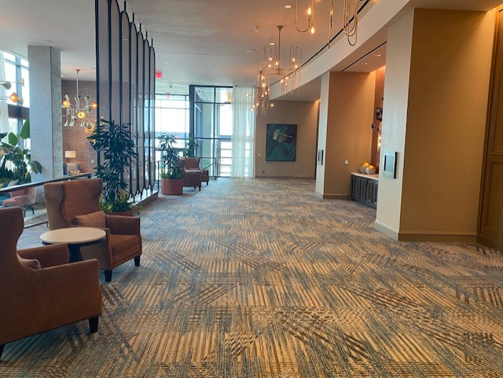

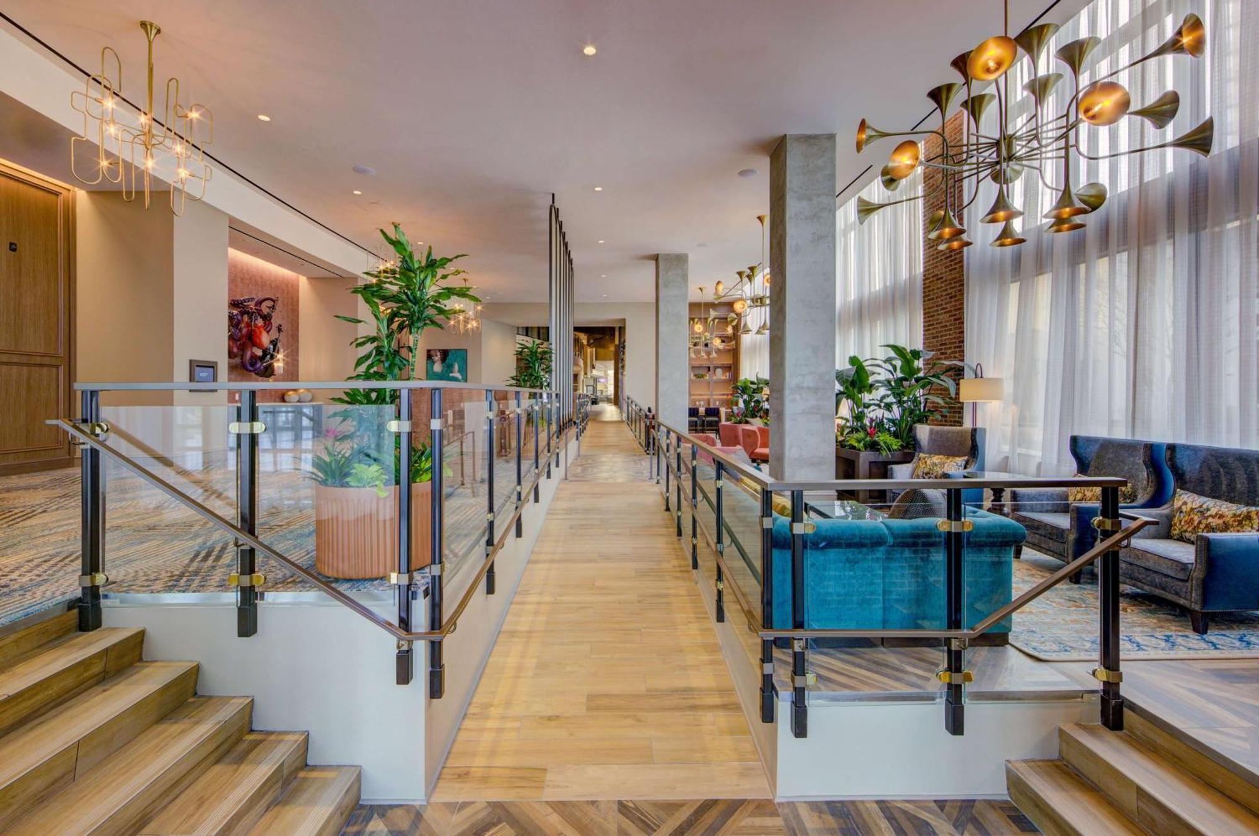

STANDARD/REGULAR BOOTH: Picture above shows the lobby/lounge area. Where you see furniture, those are booth areas and furniture can be used or removed. On the right, along the windows are more booth sites on both sides of space. Attendees will be able to enter and leave from both ends. More booth spots are located at each entrance. Side depends on vendor preference. Standard booths situated in middle.

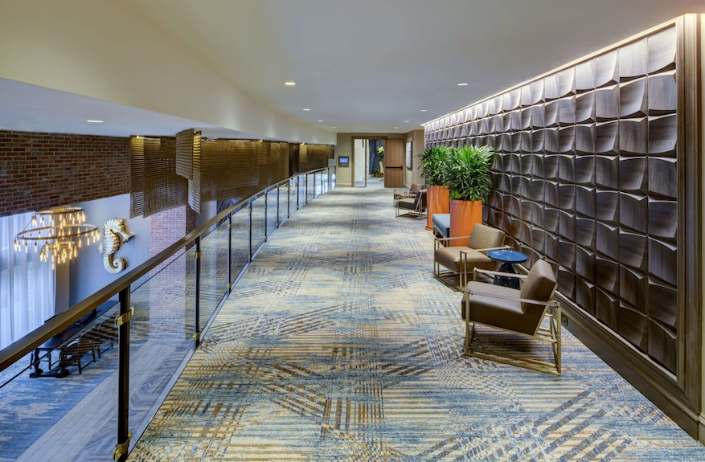
BALCONY BOOTH: Picture above of upper Mezzanine Prefunction area directly above Mainsail Walkway looking over the venue. Located outside the breakout room.

