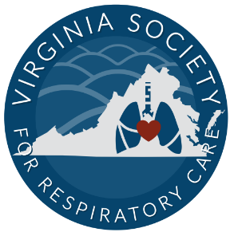
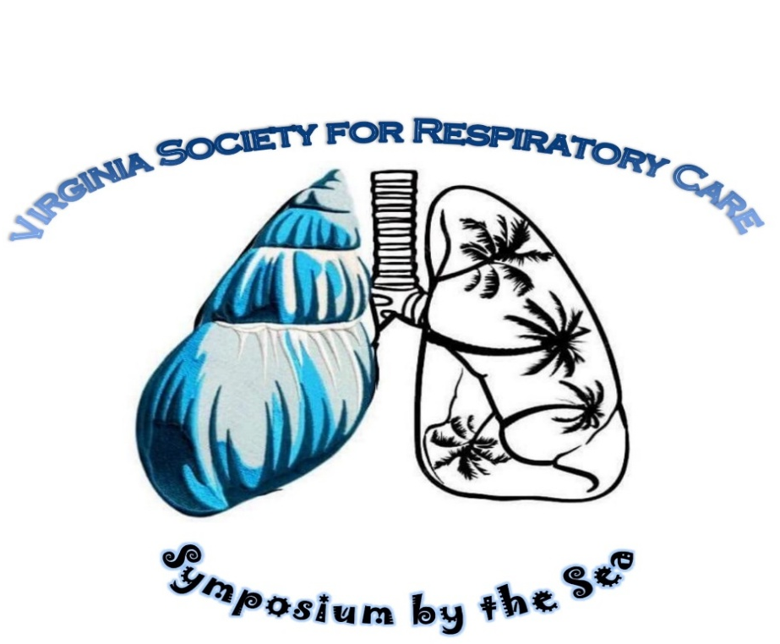
Join us for the 48th Annual

May 18th -20th 2026
Virginia Beach, VA
2026 Participant Packet
Host Hotel
Cavalier Resort
Embassy Suites
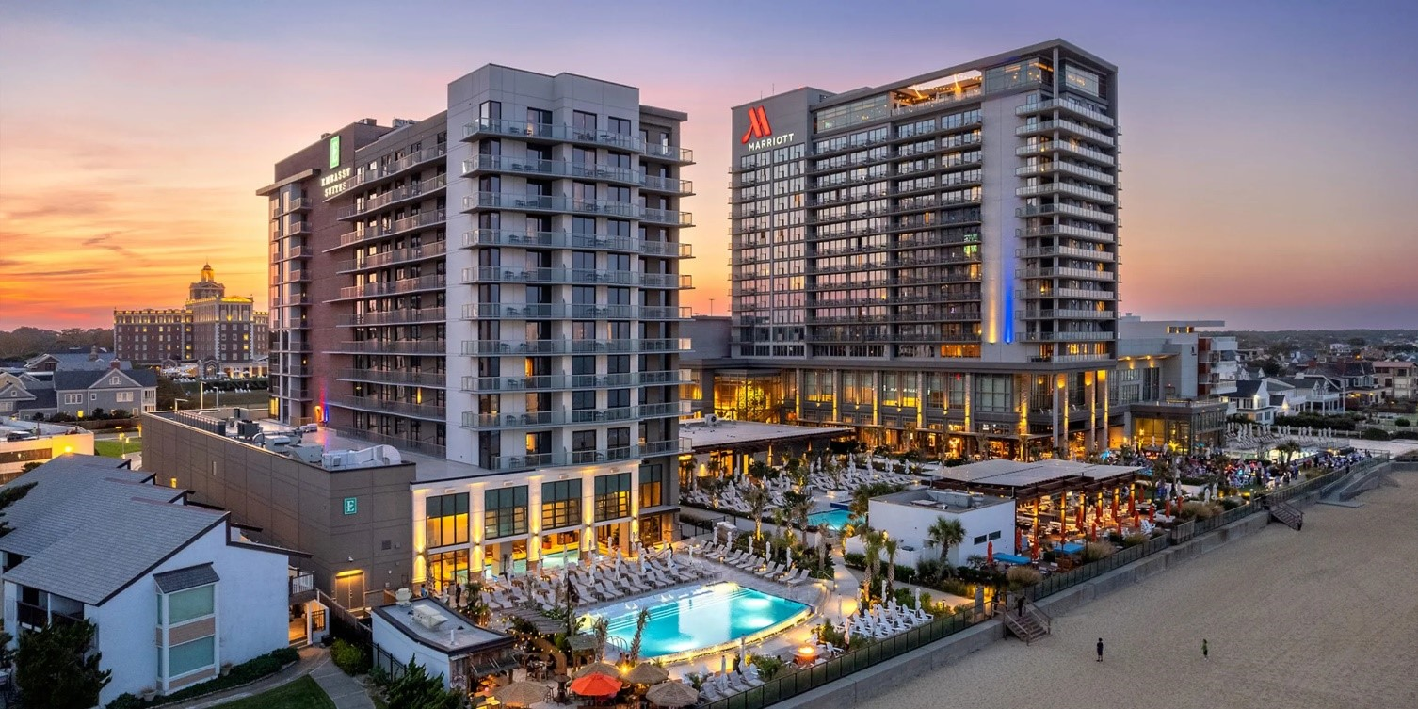
4101 Atlantic Ave, Virginia Beach, VA 23451
Phone: +1 757-228-3100


Join us for our new venue with amazing lectures, lots of fun and earn up to 16 CEUs!! Guests may make their discounted room reservation by either calling and ask for in-house reservation department and mention the VSRC using:
Link 2026 Embassy Suites Reservation Link or QR code

Room rates $219 a night (taxes and fees extra) and must be booked by April 24th, 2026 to receive this discount. Includes $25 resort fee allowing attendees to partake of free breakfast daily at on site Arbuckles Restaurant and amenities to all three hotels including: 9 restaurants and bars, 6 pools both indoor and outdoor, On-Site Distillery, just to name a few….
Registration Fees:
***Early Registration ends May 1st. Rates go up after May 1st***
 |  |  | 1 Full day | 2 Full days | Three days
AARC Member Regular |  |  | $100 | $175 | $220
Non-AARC Member Regular |  |  | $150 | $200 | $275
Student AARC Member Regular |  |  | $25 | $50 | $75
Student Non-AARC Member Reg. |  |  | $50 | $75 | $100
Active Military |  |  | $100 | $175 | $200

***May 2nd – Day of event Fees***  AARC Member Regular | $175 | $250 | $285
Non-AARC Member Regular | $200 | $275 | $320
Student AARC Member Regular | $25 | $50 | $75
Student Non-AARC Member Reg. | $50 | $75 | $100
Active Military | $100 | $175 | $200

Parking
Parking Garage on resort property across from main drive.

Self-Parking - $26 per car per night for overnight guests.
Valet parking available for additional $10.00 per day.
Daily Guest Self-Parking is $3.00 hr.


Attendee Registration is opening soon.
To register you will need to go to VSRC

Tentative Schedule of Events:
*Schedule is subject to change*
Monday May 18th (6 CRCE)
8:00 Check in
8:45 Welcome and Opening Remarks
9:00 - 10:00 Keynote speaker Emilee Lamorena – AARC Presentation
10:00 – 11:00 Eric Kriner –
“Patient-ventilator Assessment: They’re talking to us but is anyone listening?”
11:00 – 11:30 Vendor Hall opening/ Break
11:30-12:30 John Emberger – “EIT - Look in the Lungs”
12:30-1:30 Lunch provided/vendor hall
1:30 – 2:30 Hanns Billmayer – “Volumetric EtCO2”
2:30 – 3:30 Michael O’Brien – “Proposing a Theory of Caregiver Competency”
3:30 – 4:30 Keith Lamb – “Respiratory Critical Care – A Year in Review”

4:30 – 6:30 Social Night with Vendors Immediately following last presenter

Tuesday May 19th (6 CRCE)
8:00 Check in/Vendor Hall open
9:00 - 10:00 NBRC Speaker Kellie Carroll
10:00 – 11:00 John Lindsey – “Respiratory Care – More than just a profession”
11:00 – 12:00 Quyen Duong – “Understanding Oscillating Lung Expansion Therapy”
12:00-1:30 Lunch Provided (vendor hall open)
1:30 -2:30 Student Break Out Session NBRC Speaker Kellie Carroll (Upstairs board room)
1:30 Delegate Glass Presentation
1:45 – 230 Bessie Brooks and Sherleen Bose –
VSRC Delegation, Membership and Legislation Ohh Myy!!!
2:30 – 3:30 Carrie Ludwig –
“Expanding Access to Respiratory Therapy Education: A Health System–Led Workforce Solution”
3:30 - 4:30 Andrew Almond – “Impact of Attending Physician Presence During Respiratory Therapist Intubation Attempts”

5:00 – 7:00 pm Sputum Bowl
(Everyone is invited to watch our students compete and/or get your teams of 3 ready and participate)

Wednesday May 20th (4 CRCE)
8:30 – 9:30 Maria Madden –
“Breathing Beyond the Injury: Resp care and diaphragm pacing in Spinal Cord Trauma”
9:30 – 10:30 Kimberly Smith – “ECMO 101 – Exploring Basic Concepts”
10:30 – 11:00 Break
11:00 – 12:00 Karen Wockenfuss –
“Congenital Cardiac Defects from the RT: From physiology to Practice”
12:00 – 1:00 Tim Sharkey – Things you wish you knew about Respiratory Therapy

(certificate distribution after last lecture)

Any questions please email Ali Brown at VSRCVP@gmail.com or Michelle Blake Mblake@tcc.edu .

